**Manuals for ‘Manage Doctor Schedule’**

**Brief of the ‘Manage Doctor Schedule’ –** This is the page where we manage Doctors Schedule time.

**1. How to manage doctor schedule-.**

Steps:

1. Login to the site and go to ‘Specialty’ tab and click on ‘Manage Doctor Schedule’.
2. On ‘Manage Doctor schedule’ page when we select the doctor name then doctor schedule will display if there is or we can add new schedule time too.
3. On this page we can edit and delete the existing records.

1.

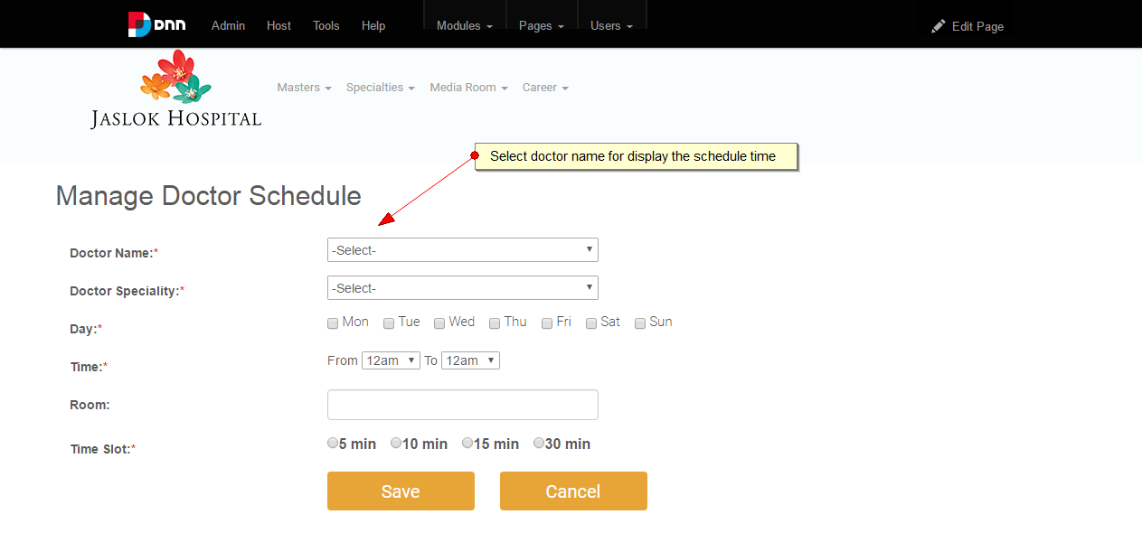

2.

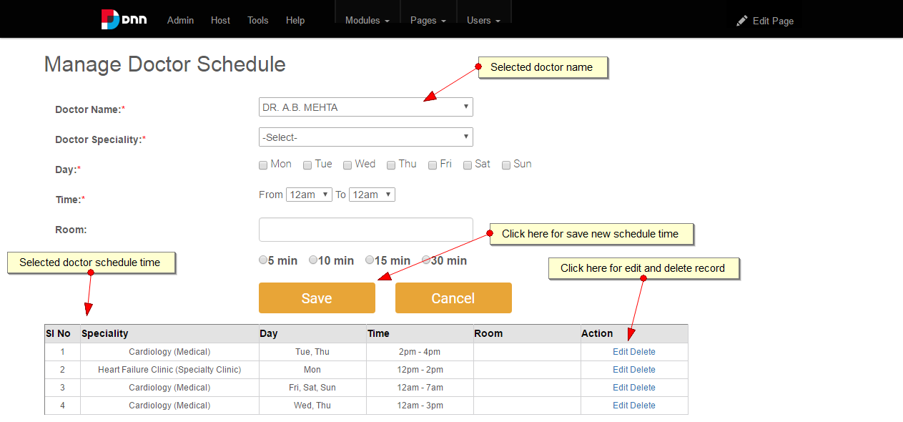

3.

